.


NATIONAL SKILL TRAINING INSTITUTE (NSTI) KOLKATA, DASNAGAR, HOWRAH

LESSON PLAN
NAME: Ankita singh TRADE/ROLL NO.: CSA /1420

UNIT/LESSON NO. 11 DATE & TIME : 23/10/2025
- PREPARATION

TITLE/TOPIC: UDP (User Datagram Protocol)

OBJECTIVES: At the end of the lesson trainee shall able to -
a) Define UDP and explain its purpose.
b) Describe features, working, and structure of UDP.

TEACHING AIDS : WHITE BOARD,MARKER,PROJECTOR,PPT,PENDRIVE, ETC.
INTRODUCTION:
REVIEW/LINK/MOTIVATION:- stream a live video, real-time Video

PRESENTATION :
OBJECTIVES | INFORMATION POINTS | SPOT HINTS
UDP (User Datagram Protocol) | UDP is a connectionless transport protocol that allows sending and receiving data (called datagrams) without establishing a connection between sender and receiver.  It is fast but unreliable, meaning it does not guarantee that data will reach its destination or arrive in the correct order. | 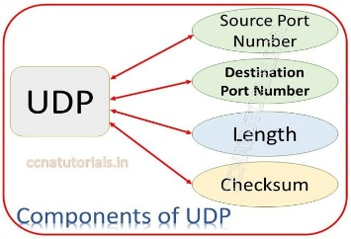

OBJECTIVES | INFORMATION POINTS | SPOT HINTS
Key Features:  How It Works:  Advantages:  Disadvantages: | Key Features:  - Connectionless: No handshake before data transfer.  - Unreliable: No acknowledgment, no retransmission if packets are lost.  - Faster: Low latency compared to TCP.  - No error correction: Only basic error detection using checksum.  - Used for real-time applications where speed is more important than reliability.  How It Works:  - Data is divided into datagrams.  - Each datagram has a header (with source and destination port numbers) and data.  - Sent directly to the destination without ensuring delivery.  UDP Header Format (8 bytes):  Field Size Description  Source Port 2 bytes Port number of sender  Destination Port 2 bytes Port number of receiver  Length 2 bytes Total length of UDP header and data  Checksum 2 bytes Error detection  Advantages:  - Very fast (no connection setup).  - Low overhead.  - Good for real-time communication.  Disadvantages:  - Unreliable (no guarantee of delivery).  - No sequencing (packets may arrive out of order).  - No flow control or congestion control.  Application Description  Online games Real-time updates; speed matters more than reliability  Video streaming Small data loss acceptable  Voice over IP (VoIP) Continuous voice packets  DNS (Domain Name System) Quick query–response  Broadcast & multicast One-to-many communication | 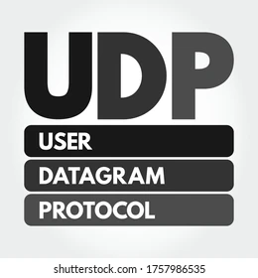  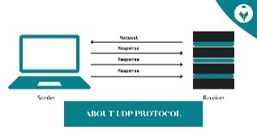
- APPLICATION :
a) Define UDP
b) Write any three advantages and three disadvantages of UDP.

SUMMARY : To repeat the objectives/main points once again.
Repeat the 2nd step in short
- TEST/QUESTIONS :
a) What is UDP?
b) What is the size of UDP header?

ASSIGNMENT:
- Which field in the UDP header checks for errors?

Reference: Copa Book , Internet, Google

NEXT LESSON: TCP



NATIONAL SKILL TRAINING INSTITUTE (NSTI) KOLKATA, DASNAGAR, HOWRAH

INFORMATION SHEET

TITLE/TOPIC: UDP

INFORMATION: UDP is a connectionless transport protocol that allows sending and receiving data (called datagrams) without establishing a connection between sender and receiver.
It is fast but unreliable, meaning it does not guarantee that data will reach its destination or arrive in the correct order.


Key Features:
- Connectionless: No handshake before data transfer.
- Unreliable: No acknowledgment, no retransmission if packets are lost.
- Faster: Low latency compared to TCP.
- No error correction: Only basic error detection using checksum.
- Used for real-time applications where speed is more important than reliability.

How It Works:
- Data is divided into datagrams.
- Each datagram has a header (with source and destination port numbers) and data.
- Sent directly to the destination without ensuring delivery.

UDP Header Format (8 bytes):

Field | Size | Description
Source Port | 2 bytes | Port number of sender
Destination Port | 2 bytes | Port number of receiver
Length | 2 bytes | Total length of UDP header and data
Checksum | 2 bytes | Error detection

Advantages:
- Very fast (no connection setup).
- Low overhead.
- Good for real-time communication.

Disadvantages:
- Unreliable (no guarantee of delivery).
- No sequencing (packets may arrive out of order).
- No flow control or congestion control.

Application | Description
Online games | Real-time updates; speed matters more than reliability
Video streaming | Small data loss acceptable
Voice over IP (VoIP) | Continuous voice packets
DNS (Domain Name System) | Quick query–response
Broadcast & multicast | One-to-many communication

